Personal Budget & Expense Tracker

Week one assignment

Name: NOOR AWEYS HASSAN

This provides the skeleton structure requested in Parts 1, 2, and 3.
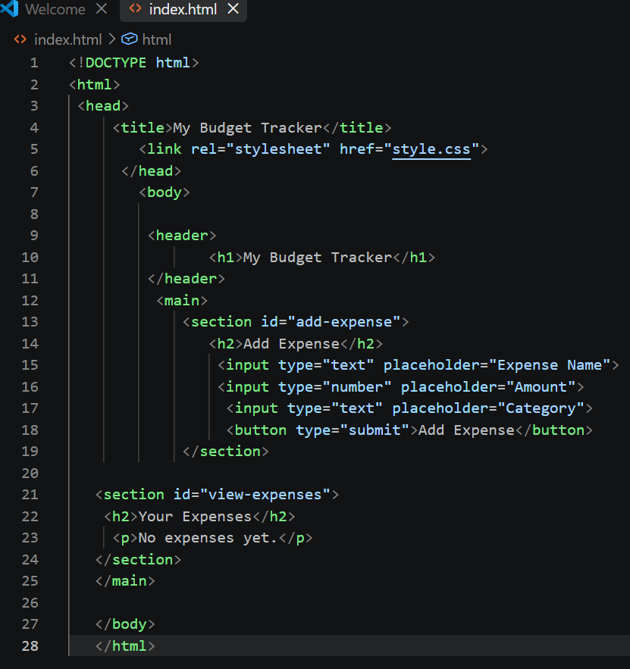This provides the skeleton structure requested in Parts 4.
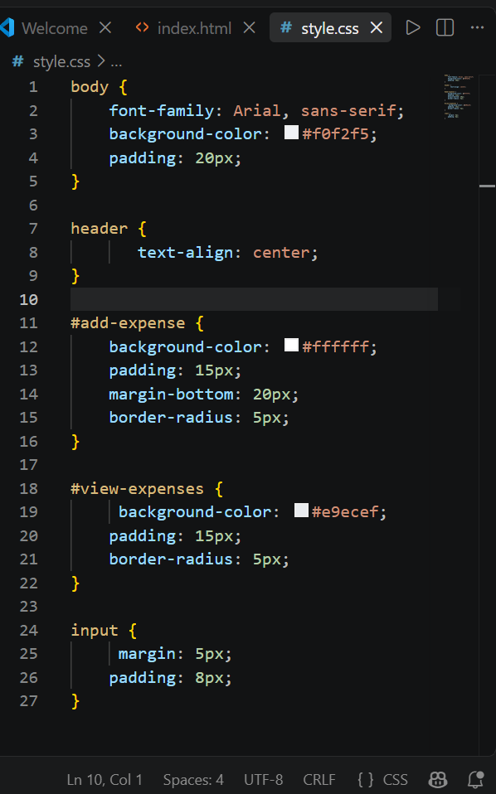
Test it in Google Docs And DevTool

